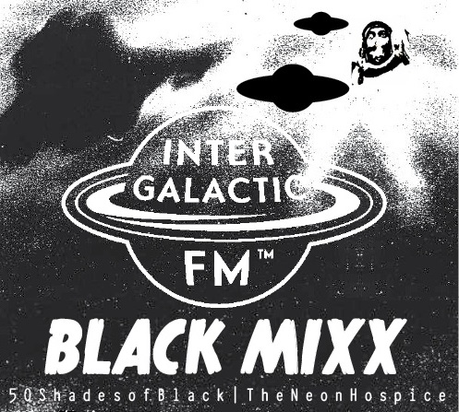
01. Crawling With Tarts – Plowing And Tilling
02. Maria Zerfall In Phase Pervers – Zerfall
03. Nimam Spregleda – Walk Thru Woods
05. Salaried Man Club – Gray Cross
06. Cut With The Kitchen Knife – Nocturnal Diseases
07. The Horse He's Sick – Pulp
C y b e r n e t i c B r o a d c a s t i n g S y s t e m
C. G l ö O m y - I n t e r g a l a c t i c B l a c k M i x x
5 0 S h a d e s o f B l a c k | T h e N e o n H o s p i c e

